|  |  |
| --- | --- |
| C:\Users\ccomputer\Desktop\aalogo1.jpg | **Alumni Association**  **of**  **Government College of Engineering, Aurangabad**  **(AAGECA)**  **c/o Govt. College of Engg. Aurangabad, Osmanpura, Station Road, Aurangabad- 431 005**  **Website:** [**www.gecaalumni.org**](http://www.gecaalumni.org) **Email:** [**gecaalumni555@gmail.com**](mailto:gecaalumni555@gmail.com) |

**Report for SAT activities conducted for year 2023-24**

On October 22, 2023, the Alumni Association of Government College of Engineering Aurangabad held a significant event in the IT seminar hall to inaugurate the Student Alumni Team (SAT). This ceremony, a collaborative effort between the alumni association and college administration, marked a milestone in fostering connections between past and present members of the college community. The occasion was graced by alumni, faculty, and students, highlighting the strong support for the college's development.

The inauguration of the SAT team symbolized a substantial investment in the college's future, supported generously by the alumni association. Speeches from alumni, faculty, and guests emphasized the team's potential to empower students and drive innovation, inspiring the current student body to utilize this new resource effectively. The event concluded with optimism for the college's continued growth.

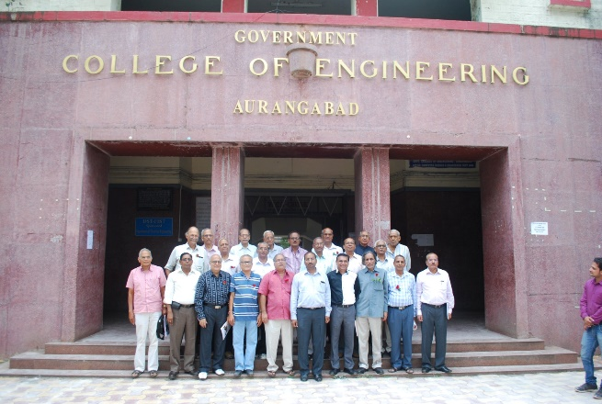 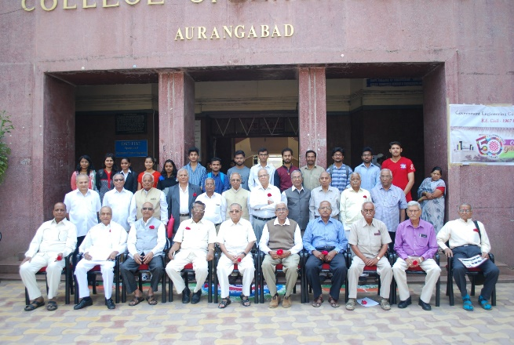

Later, on December 27, 2023, the 1976 batch of alumni returned for a nostalgic reunion at Government College of Engineering Aurangabad. Fifteen alumni gathered amidst warm receptions and a sumptuous lunch, renewing old friendships and reminiscing about their college days. The event celebrated enduring bonds within the college community, reinforcing the importance of alumni support over the years.

Following this, on January 30, 2024, the 1981 batch of alumni also reunited at their alma mater, greeted with similar warmth and camaraderie. Twenty alumni participated in a morning reception and breakfast, continuing conversations about their shared experiences and individual achievements since graduation. This event echoed the sentiment of lifelong connections fostered through the college experience.

The Government College of Engineering Aurangabad hosted its Annual Alumni Meet on March 10, 2024, featuring a blend of nostalgia, professional networking, and celebration of alumni accomplishments. The evening commenced with distinguished guests including N.D. Deshmukh and Jayant Deo, alongside college leadership and alumni association members. Alumni engaged in panel discussions, sharing industry insights and advice with current students, while structured networking sessions facilitated new collaborations and career opportunities.  
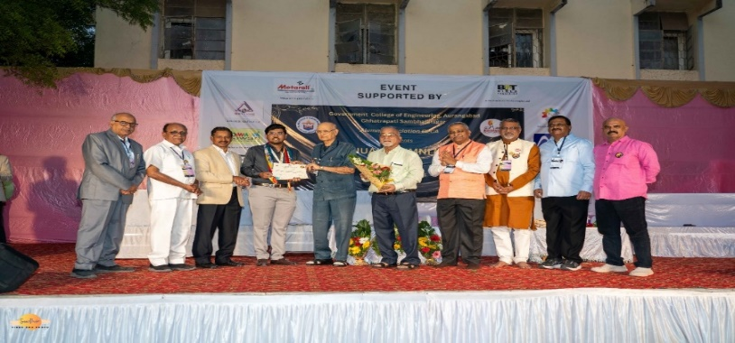

Highlighting the event were awards recognizing outstanding alumni and student achievements. Pritam Nikumbh received the Best Outgoing Student award, while various student teams were acknowledged for their excellence in engineering competitions. Cultural performances added to the celebratory atmosphere, showcasing the college's vibrant spirit and community pride.

Additionally, during the meet, the Patney Engineering Gold Medal was awarded to Pritam Nikumbh, sponsored by alumni M.B. Patni. This prestigious award, presented with a cash prize and certificate, underscored the importance of academic excellence and perseverance, inspiring current students to strive for similar achievements.

On the same occasion, Mayuri Sangekar, an esteemed alumna, presented the Most Outstanding Civil Engineering Student Award to a deserving third-year student. This award highlighted academic excellence and contributions to the field of civil engineering, reinforcing the bond between alumni and current students in pursuit of excellence.

Concluding the academic year, the SAT team bid farewell to its final year members on May 6, 2024. The event honored their dedication and leadership, particularly recognizing Vishant Charak for his outstanding stewardship. Certificates and a trophy were presented as tokens of appreciation, celebrating the team's achievements and highlighting the importance of teamwork within the college community.